ECEN 340
Lab #9

Timing Evaluation and Improvement

Purpose:
1. To learn how to use Vivado’s timing analysis tools
2. To learn how to make use of Vivado’s “Device” view for timing analysis.
3. To learn how to predict the maximum operating frequency of the design.
4. To become familiar with the Artix 7 structure.
5. To learn how to make timing improvements.

Overview:
The first objective of this lab is to evaluate the timing of Lab 8’s memory design to determine it’s maximum operating frequency for:

A) An 8-bit adder using the “+” operator
B) An 8-bit multiplier using the “*” operator
C) An 8-bit multiplier using the instantiation of Lab 5, the continuous assignment (data-flow) multiplier.

In other words, for part B, you will replace the “+” operator in lab 8 with an instantiation of your Lab 5 multiplier in order to evaluate its maximum speed. For part C, you must write a new and improved multiplier module.

The final objective of this lab is to speed up the clock rate of the multiplier by pipelining the design for part C.

Part 1 (First lab day).
- Make sure the “create_clock” line is uncommented in the constraints file. This line will set up the timing constraints for the analysis. The period for the analysis will be 10ns.
- In Vivado, execute the Lab 8 memory project all the way to the “Implementation” stage, and open the implemented design.
- Under the “Implementation” menu, select “Edit Timing Constraints” to make sure the timing will be evaluated at a 10ns period.
- Under the same menu, select “Report Timing Sumary”. Use the default settings and generate the summary.
- Record the “Worst Negative Slack” number. A positive number will indicate the design meets timing requirements.
  - 2.741 ns
- Click on the WNS number and you will be able to view the timing of each path. The default view shows the slowest path first.
- Record the path starting point and the path stoping point for the 4 worst paths.
  - Addrcont/addr_reg[1]/C OM/mem_reg_0_15_8_8/SPI/I
  - Addrcont/addr_reg[1]/C OM/mem_reg_0_15_4_4/SPI/I
  - Addrcont/addr_reg[1]/C OM/mem_reg_0_15_7_7/SPI/I
  - Addrcont/addr_reg[1]/C OM/mem_reg_0_15_5_5/SPI/I

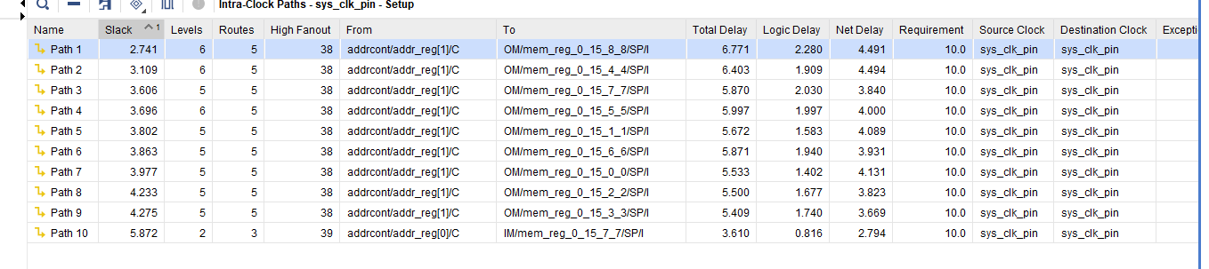
- Activiate the “Schematic” view and observe what happens as you select different paths in the timing report.
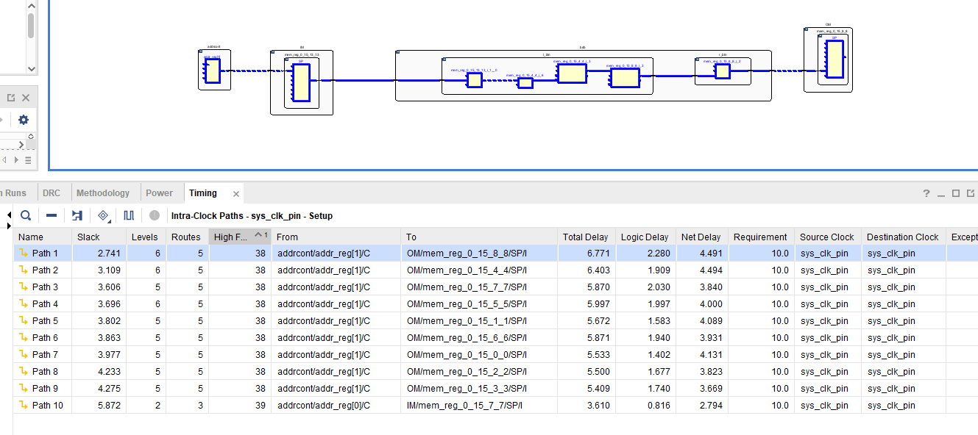
- Activate the “Device” view and make the same observation (you will need to zoom way in!).
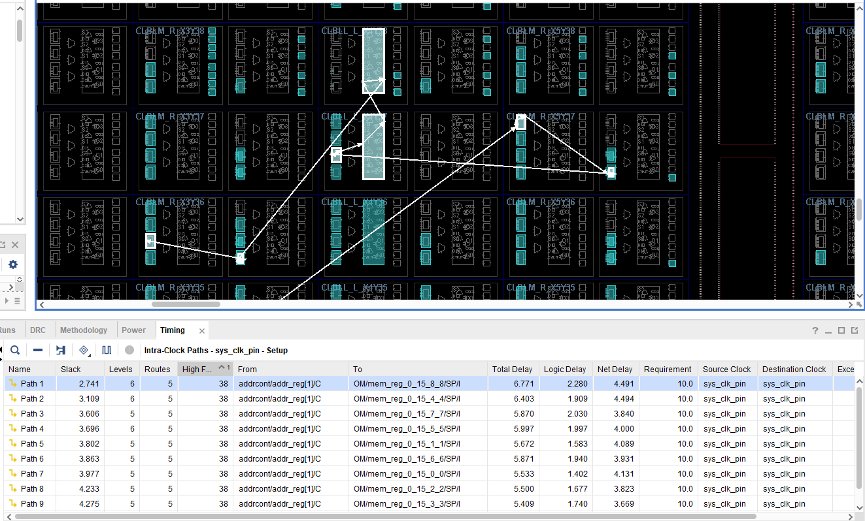
- Repeat this process for the “*” operation instead of the “+” operation.
Worst Negative Slack (WNS): 0.249 ns

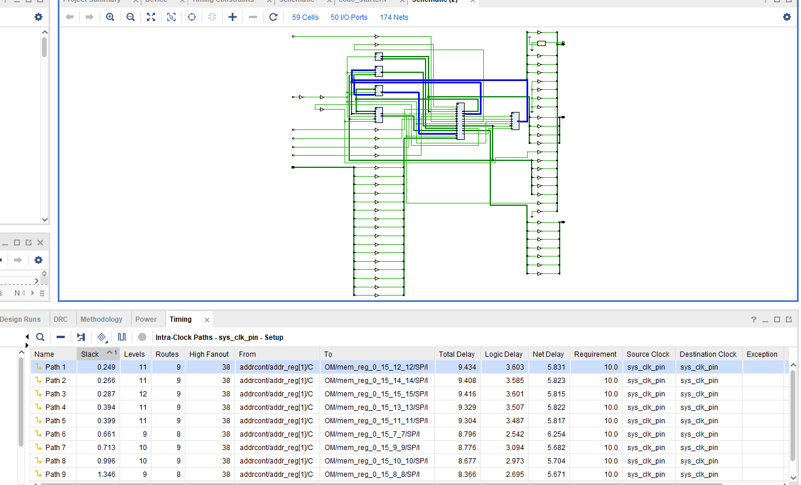

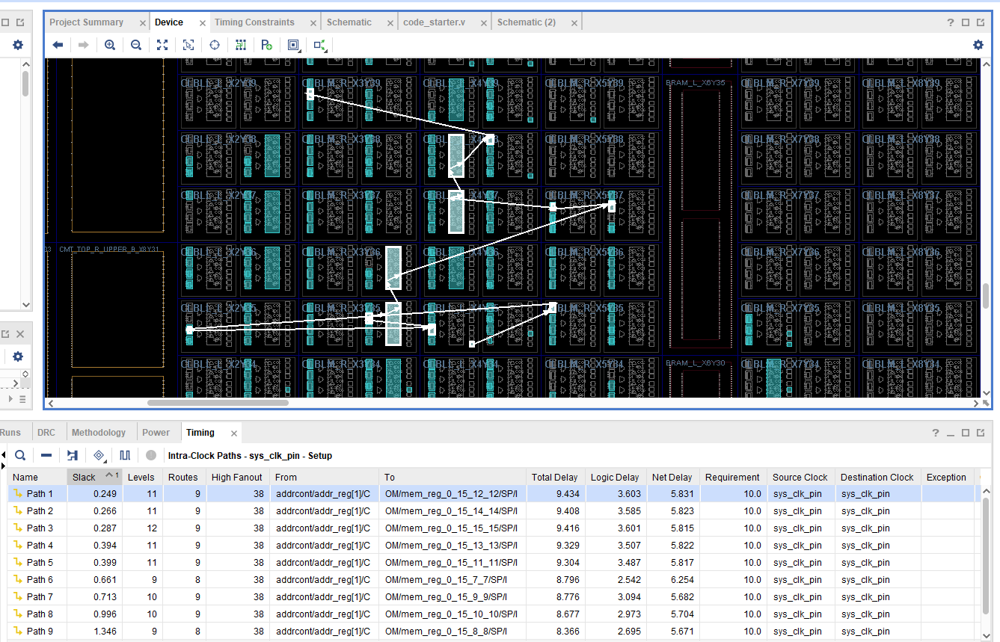
- Repeat the process again for the Lab 5 Data-flow Multiplier (instantiate the Lab 5 multiplier in the memory lab).
WNS: infinity
Path from start to finish: N/A
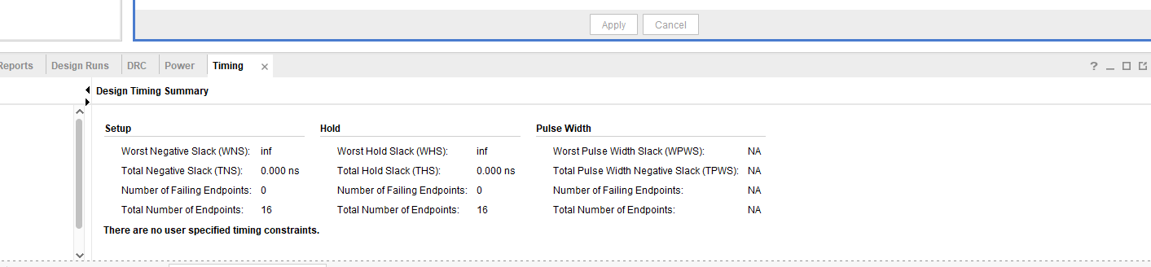

Part 2 (Second lab day).
Implement a pipelined multiplier and evaluate it’s speed by instatiating it into your lab 8 sequential memory.

WNS at 158MHz for pipelined multiplication, period at 6.3nS:

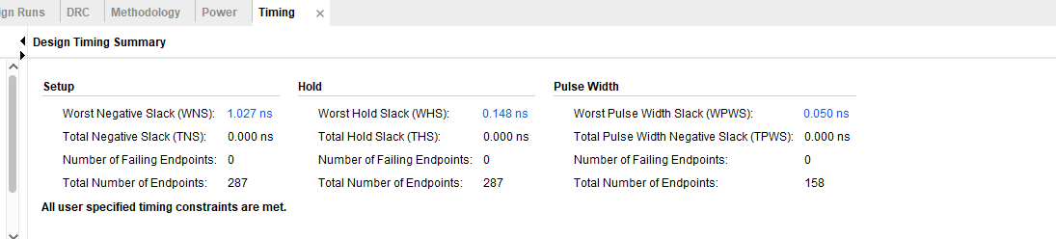

WNS at 100Mhz, period = 10nS:

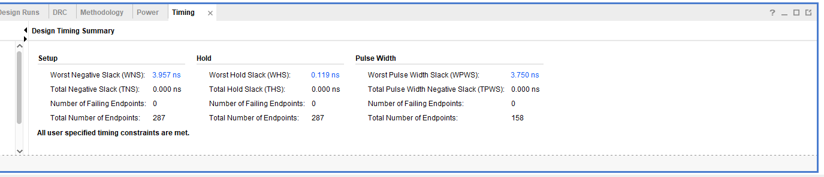
Since pipelining takes multiple clock cylcles to complete a multiplication operation, the result won’t be ready until a few clock cycles after the input memory is accessed.

What must you do in order to force the product of the input memory data to be written to the coresponding address in output memory?

Pipelining Hint: If product = p0 + p1 + p2 + p3 + p4 + p5 + p6 + p7 (see lab 5), it is possible to pipeline the operation in using the technique in Figure 1.
p0
p5
p4
p3
p2
p1
D
Q
D
Q
D
Q
D
Q
D
Q
D
Q
product
p7
p6

Figure 1, Pipelining the Partial-Product Sums

Submitting your report:
Please submit a combined report for both parts of this lab which includes the following:

1) A copy of the new Verilog code used to implement the design(s). The Verilog code (including test bench code) should be complete with useful comments (5 pts).

2) A brief description of the unique (new) tools, technologies, or methods used to implement this lab (5 pts).

3) Please include Vivado screen shots of the implemented design, etc., to make it easier to document your work (5 pts).

4) In your conclusion statement, please discuss your prediction for the maximum operating frequency of each evaluation. You should also discuss the advantages and disadvantages of pipelining. (10 pts).

